**HBS Dealer Settings:** When you first open CNH Connect (CSPS), you will want to check the Dealer Settings tab under the Configuration heading first. This screen holds your dealership’s CSPS login information and CNH dealer identification, which the system validates with CSPS to make sure you are a CNH dealer and therefore permitted to use this service.

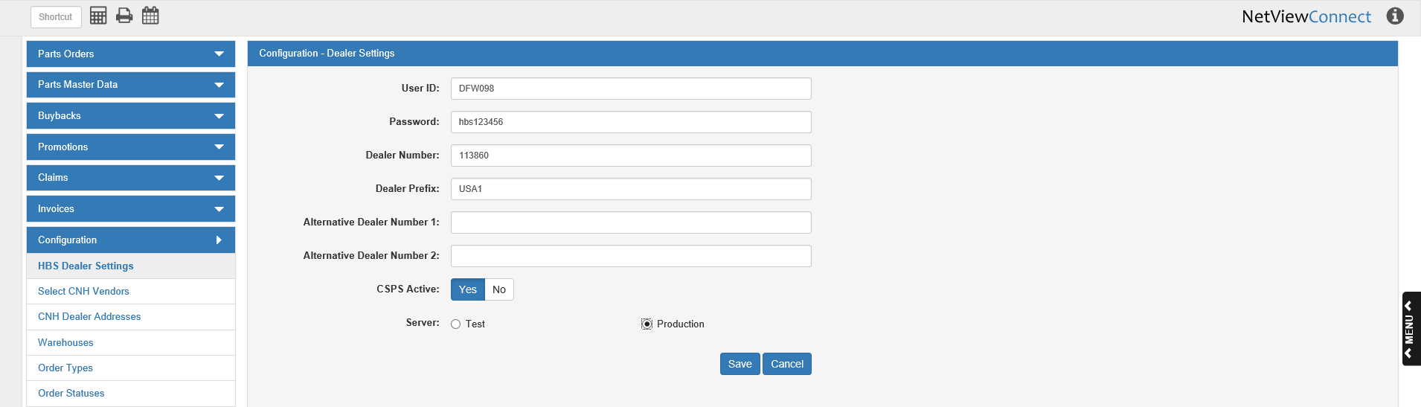

**Field Definitions:**

User ID: Enter your CSPS user ID here.

Password: Enter your CSPS password here.

Dealer Number: Enter your CNH dealer number here.

Dealer Prefix: Enter your CNH dealer prefix here.

* For **U.S.** dealers, that should be “USA1.”
* For **Canadian** dealers, that should be “CAN1.”

Alternate Dealer Number 1 & 2: If CNH has assigned you any alternate dealer numbers you may enter them in these two fields.

CSPS Active: In order to activate CSPS on your system, this must be set to **Yes**. If it is set to “No,” you will not be able to use CSPS.

Server: Make sure this field is set to **Production**. If it is set to “Test,” you will not be able to process your orders.

**Save:** Click this button to save your information.

**Cancel:** Click this button to cancel any changes made to the page that have not been saved.